Website Project: SET Services (Student Expense Tracker)
Group Members: Jerome Sabanal and Nathalie Faye L Peter
Goal: The Student Expense Tracker is designed to help students keep track of their money by recording their income, expenses, and remaining balance. The website shows a summary of the user’s activities and allows them to organize their income and expenses into different categories based on their purpose. It also includes a description section where users can add details to each transaction, making it easier to remember where their money went. Overall, the system helps students become more aware of their spending habits and manage their finances better.
WEBSITE USER INTERFACE:
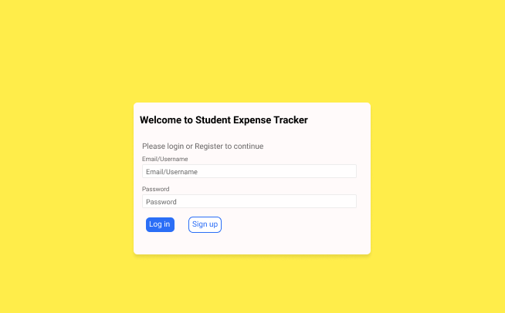

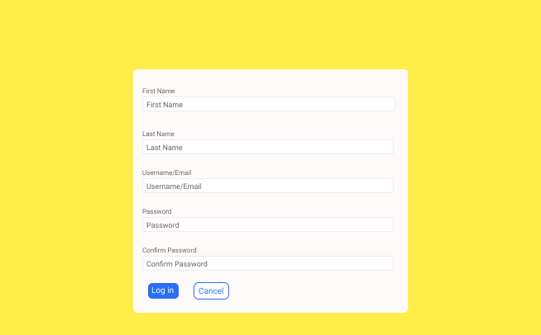

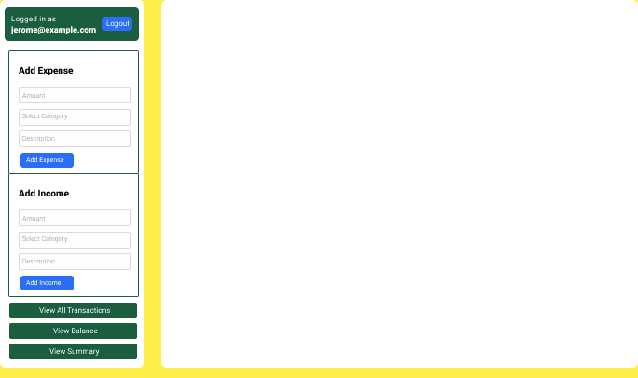

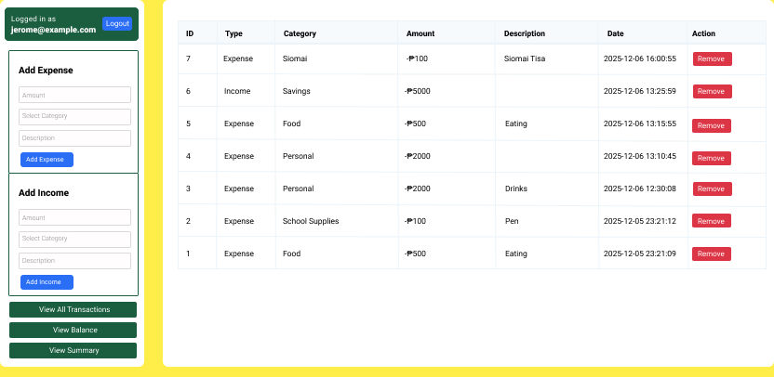

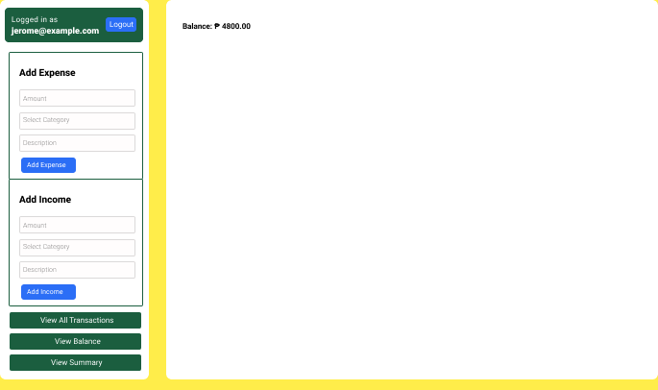

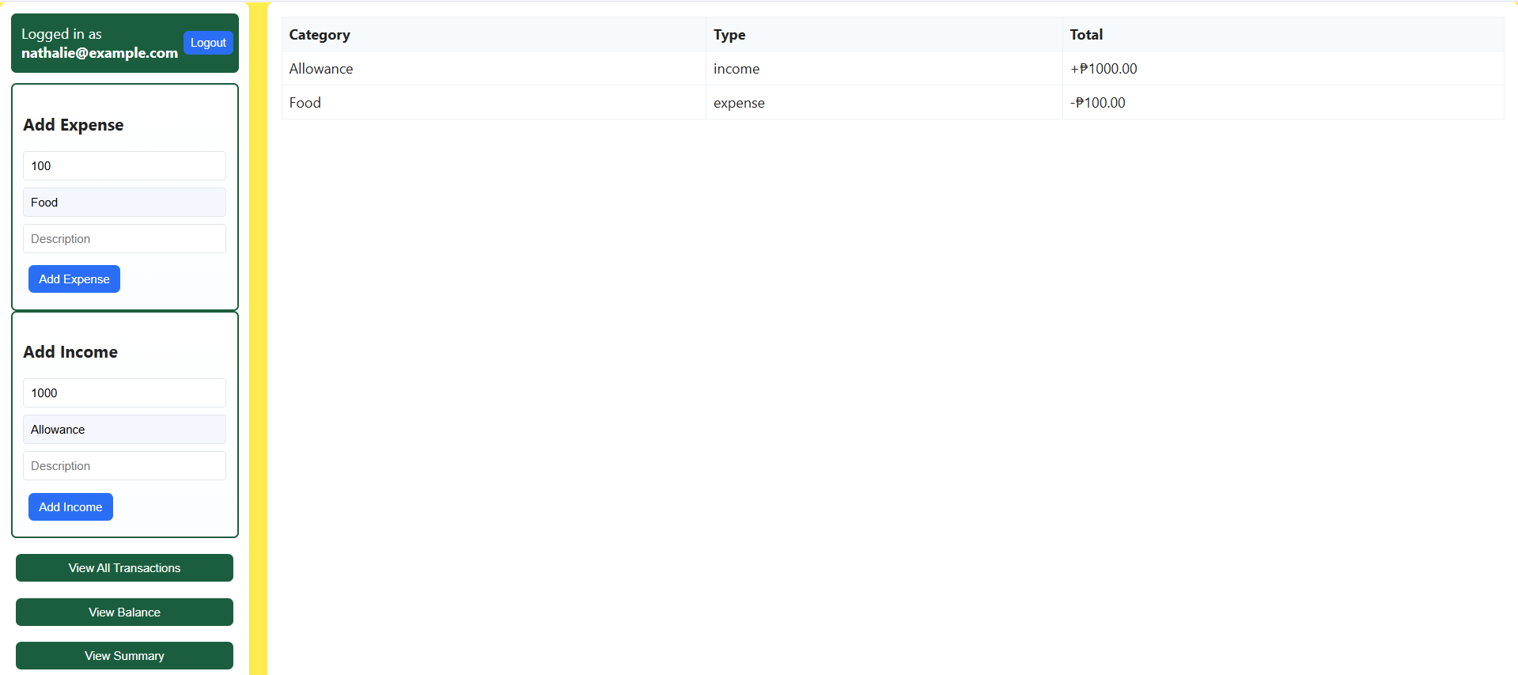

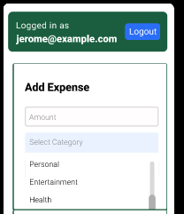
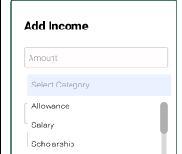

USE CASE DIAGRAM:
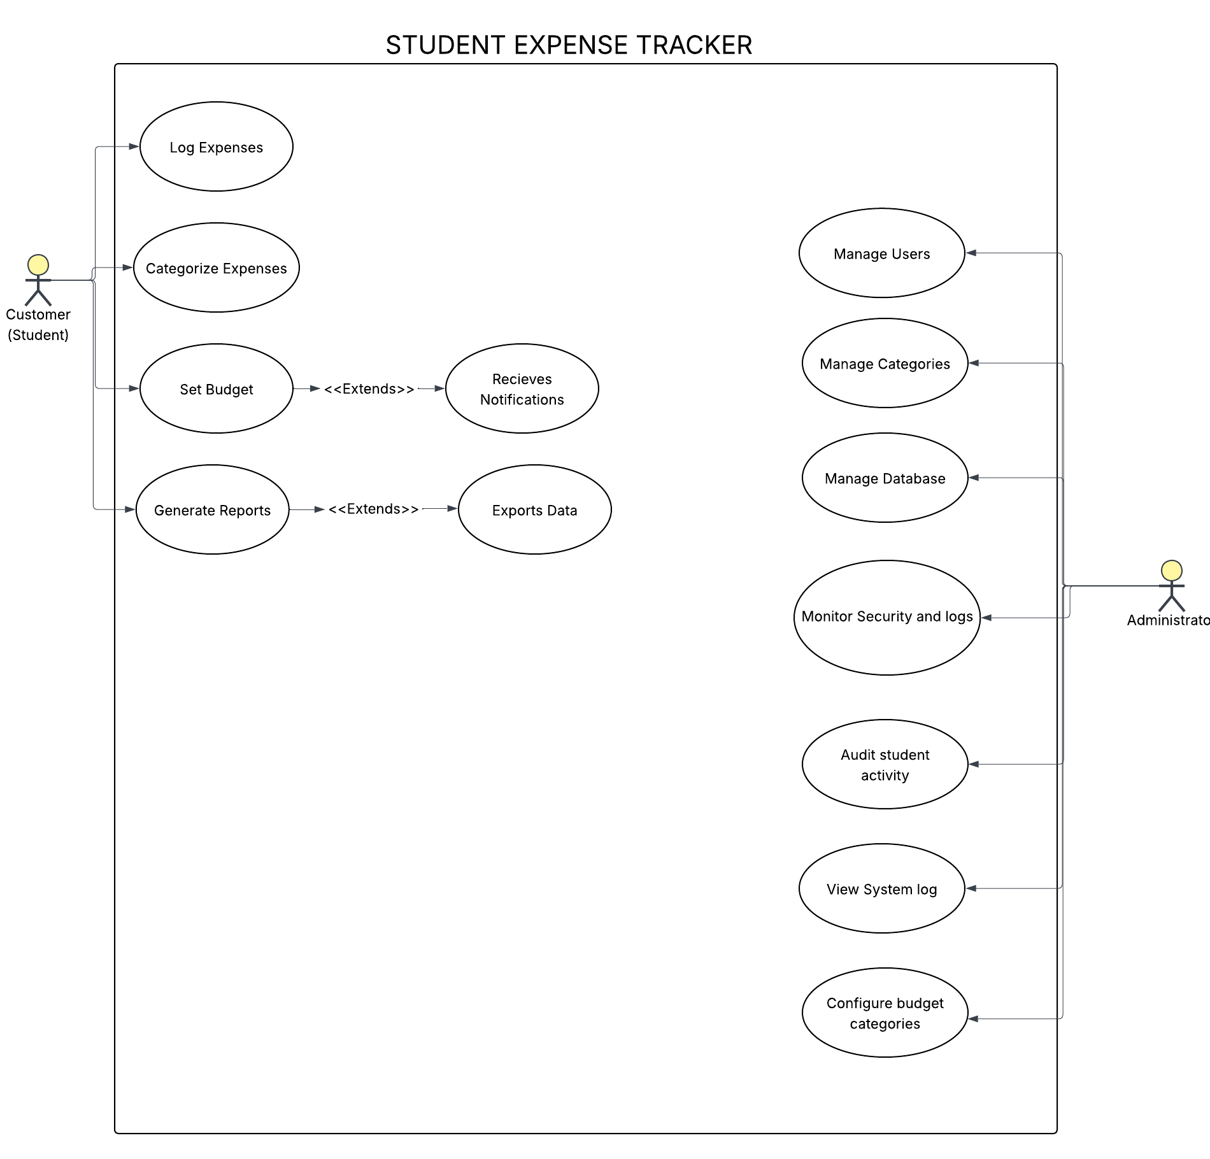

CLASS DIAGRAM:
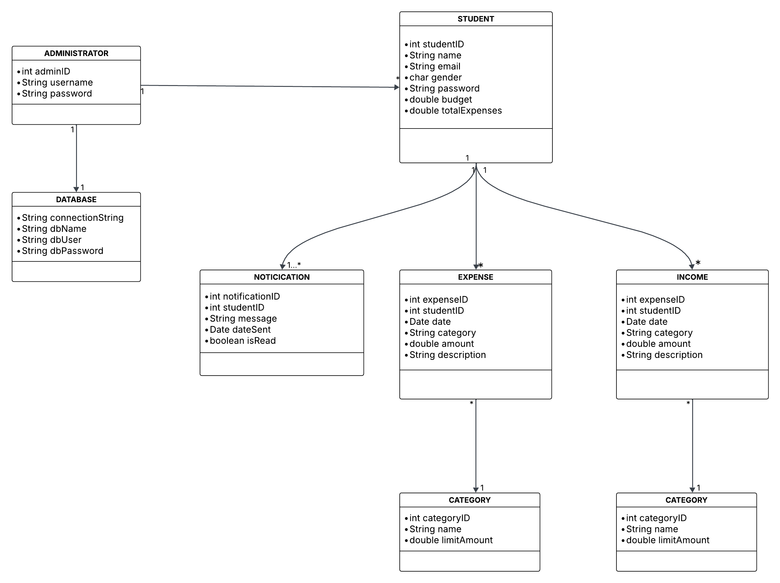

S

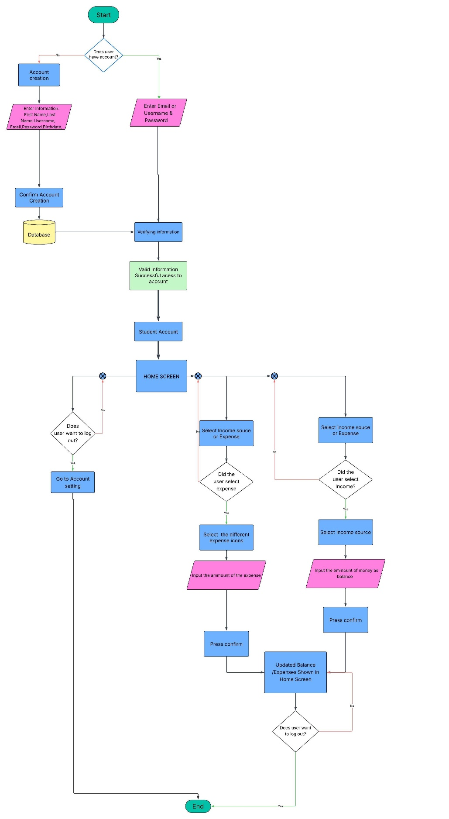
PROCEDURAL:

